1. Competitor Research: 3 Key Competitors
Here are three major competitors Ola Electric would consider in the Indian EV market:
- Ather Energy.
- TVS iQube
- Bounce Infinity
2. Unique Selling Points (USPs) for Ola Electric
- High-Performance Electric Rides
- Long Battery Range
- Fast Charging with Ola Hypercharger Network
- Zero Emissions & Sustainable Mobility
- Smart Connectivity
3. X Ads Campaign Setup
a) Selected Objective
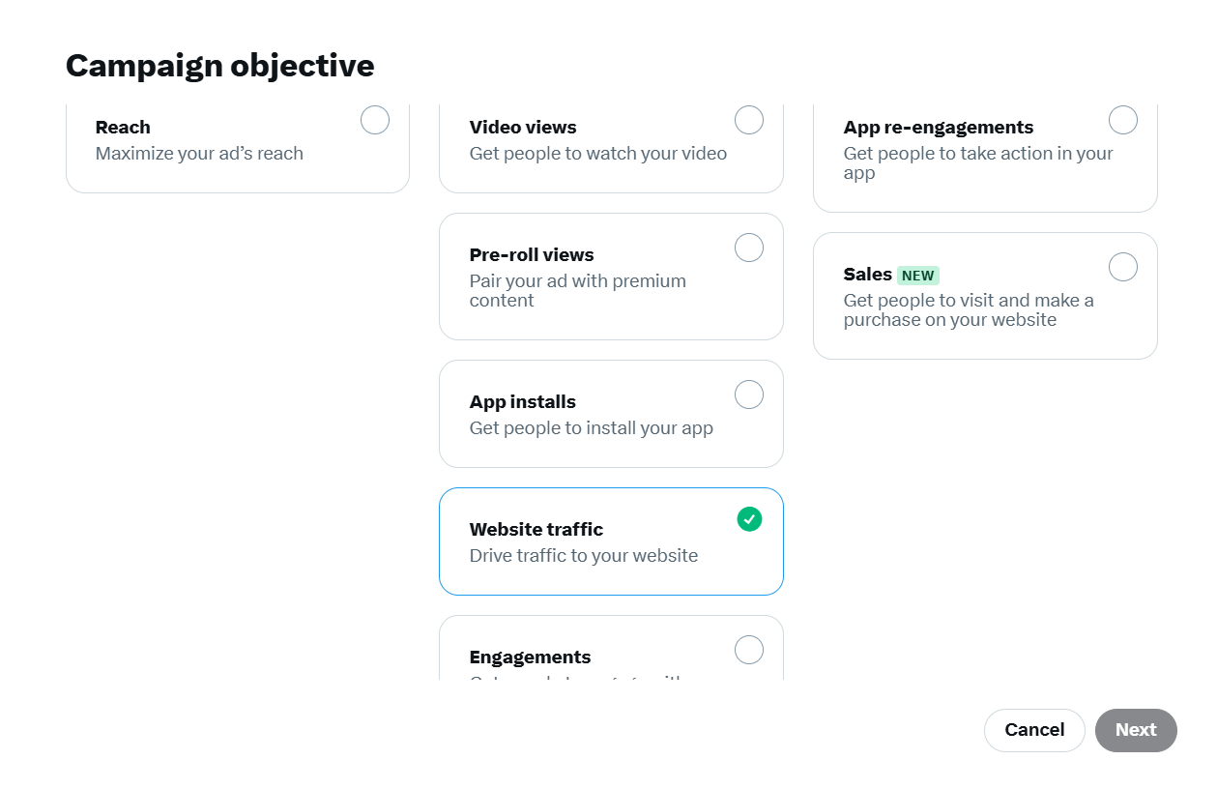
b) Budget Setup
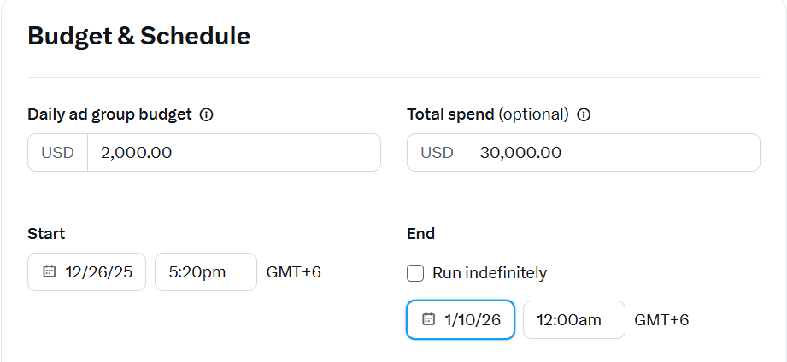
c) Audience Targeting
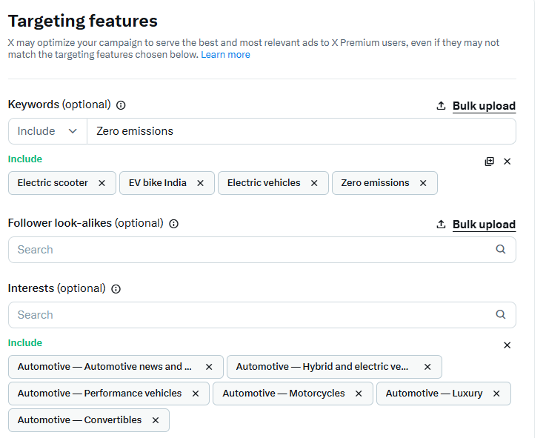
4. Ad Preview (Text + Headline + CTA)
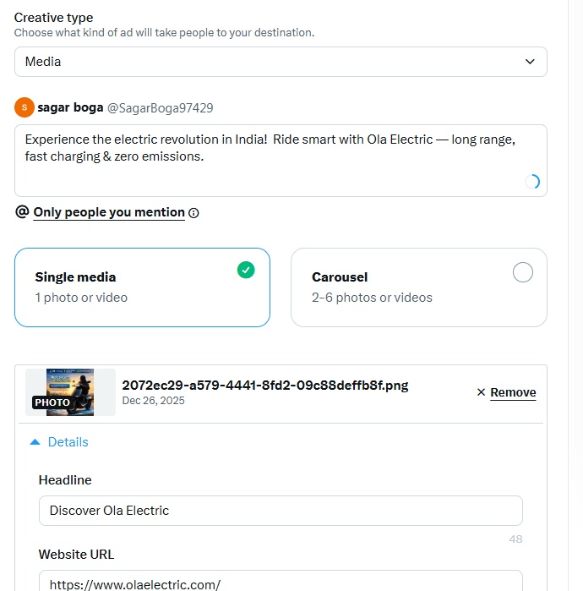
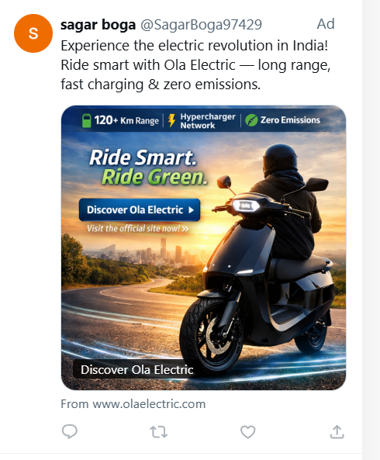
5. Estimated Campaign Results
